**Industrial Internship Report on**

**”Project Name”**

**Prepared by**

**[Jagdip tiwari]**

|  |
| --- |
| *Executive Summary* |
| This report provides details of the Industrial Internship provided by upskill Campus and The IoT Academy in collaboration with Industrial Partner UniConverge Technologies Pvt Ltd (UCT).  This internship was focused on a project/problem statement provided by UCT. We had to finish the project including the report in 6 weeks’ time.  My project was (crop and weed detection)  This internship gave me a very good opportunity to get exposure to Industrial problems and design/implement solution for that. It was an overall great experience to have this internship. |

**TABLE OF CONTENTS**

1 Preface 3

2 Introduction 4

2.1 About UniConverge Technologies Pvt Ltd 4

2.2 About upskill Campus 8

2.3 Objective 9

2.4 Reference 9

2.5 Glossary 10

3 Problem Statement 11

4 Existing and Proposed solution 12

5 Proposed Design/ Model 13

5.1 High Level Diagram (if applicable) 13

5.2 Low Level Diagram (if applicable) 13

5.3 Interfaces (if applicable) 13

6 Performance Test 14

6.1 Test Plan/ Test Cases 14

6.2 Test Procedure 14

6.3 Performance Outcome 14

7 My learnings 15

8 Future work scope 16

# Preface

Summary of the whole 6 weeks’ work.

About need of relevant Internship in career development.

It will surely help me to boost my growth my resume will have experience from a reputated company .

Brief about Your project/problem statement.

The objective of my project statement was to clean data using yolo increase data using data augamataion and then use machine learning algorithm to detect the object is crop ir weed

My project was crop and weed detection

Opportunity given by USC/UCT.

How Program was planned

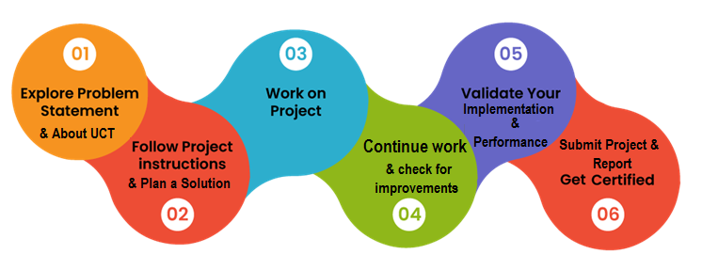

Your Learnings and overall experience.

Thank to all (iot academy), who have helped you directly or indirectly.

Your message to your juniors and peers.

Should join the course as it provide you with the excellent opportunity to excel and grow in your field.

# Introduction

## About UniConverge Technologies Pvt Ltd

A company established in 2013 and working in Digital Transformation domain and providing Industrial solutions with prime focus on sustainability and RoI.

For developing its products and solutions it is leveraging various**Cutting Edge Technologies e.g. Internet of Things (IoT), Cyber Security, Cloud computing (AWS, Azure), Machine Learning, Communication Technologies (4G/5G/LoRaWAN), Java Full Stack, Python, Front end**etc.

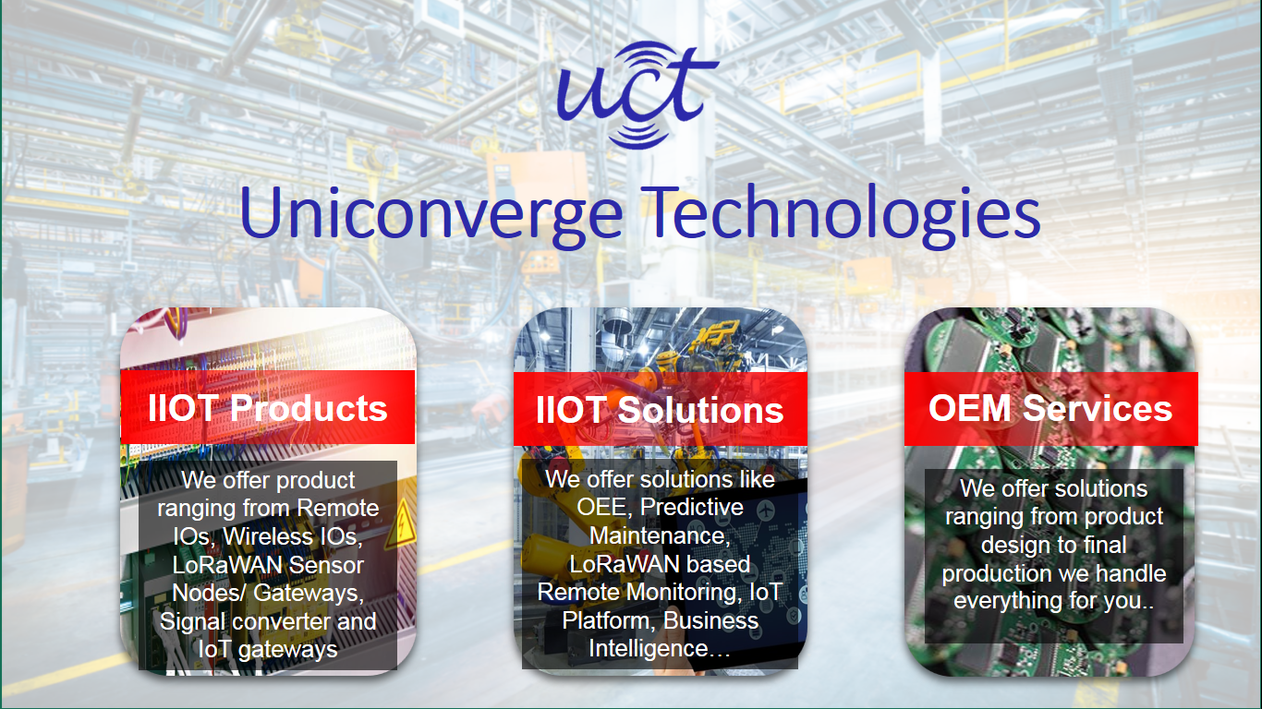

1. UCT IoT Platform **(****)**

**UCT Insight** is an IOT platform designed for quick deployment of IOT applications on the same time providing valuable “insight” for your process/business. It has been built in Java for backend and ReactJS for Front end. It has support for MySQL and various NoSql Databases.

* It enables device connectivity via industry standard IoT protocols - MQTT, CoAP, HTTP, Modbus TCP, OPC UA
* It supports both cloud and on-premises deployments.

It has features to  
• Build Your own dashboard  
• Analytics and Reporting  
• Alert and Notification  
• Integration with third party application(Power BI, SAP, ERP)  
• Rule Engine

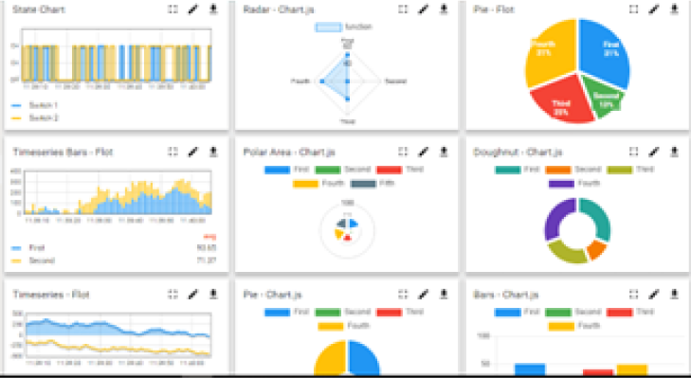 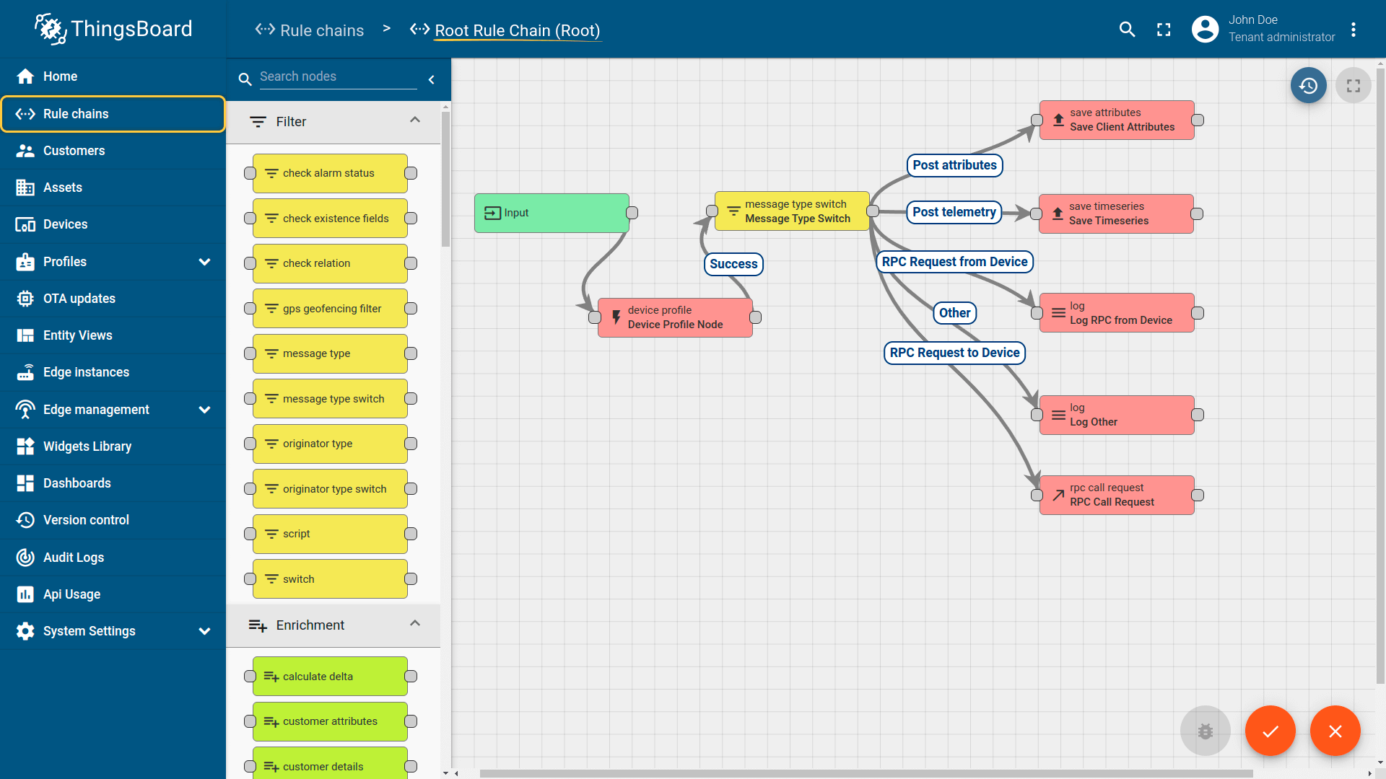

1. **Smart Factory Platform (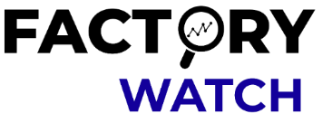)**

Factory watch is a platform for smart factory needs.

It provides Users/ Factory

* with a scalable solution for their Production and asset monitoring
* OEE and predictive maintenance solution scaling up to digital twin for your assets.
* to unleased the true potential of the data that their machines are generating and helps to identify the KPIs and also improve them.
* A modular architecture that allows users to choose the service that they what to start and then can scale to more complex solutions as per their demands.

Its unique SaaS model helps users to save time, cost and money.

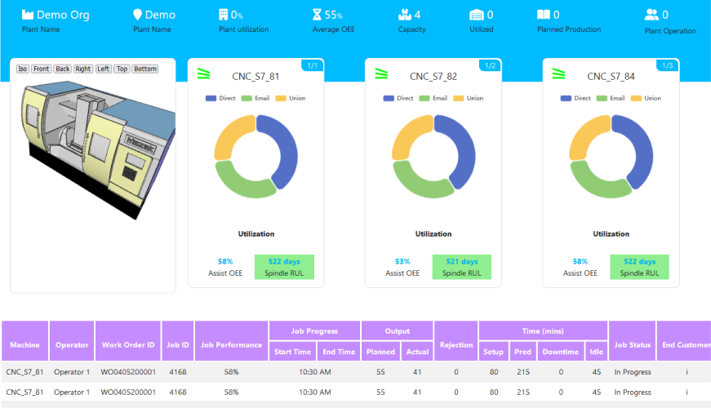 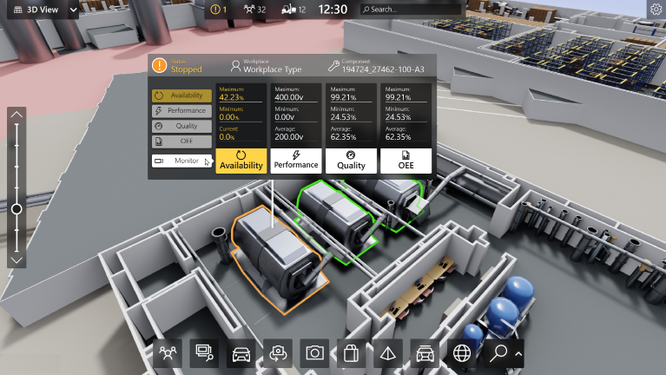

1. 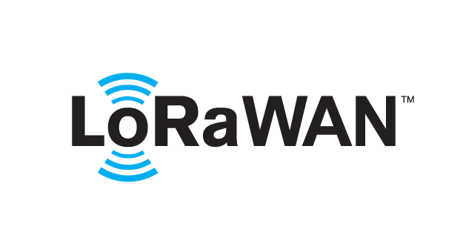 based Solution

UCT is one of the early adopters of LoRAWAN teschnology and providing solution in Agritech, Smart cities, Industrial Monitoring, Smart Street Light, Smart Water/ Gas/ Electricity metering solutions etc.

1. Predictive Maintenance

UCT is providing Industrial Machine health monitoring and Predictive maintenance solution leveraging Embedded system, Industrial IoT and Machine Learning Technologies by finding Remaining useful life time of various Machines used in production process.

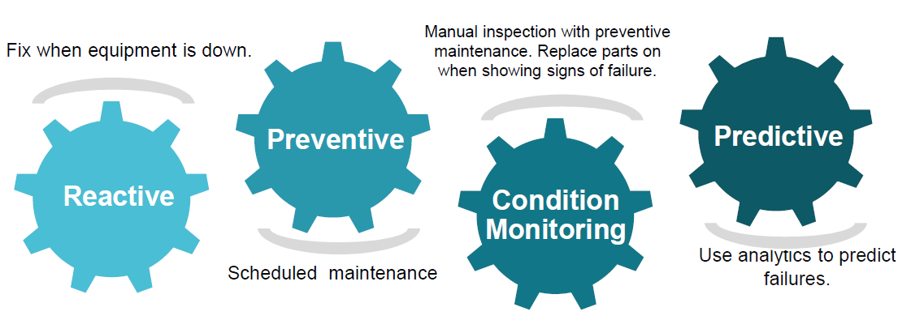

## About upskill Campus (USC)

upskill Campus along with The IoT Academy and in association with Uniconverge technologies has facilitated the smooth execution of the complete internship process.

USC is a career development platform that delivers **personalized executive coaching** in a more affordable, scalable and measurable way.



Seeing need of upskilling in self paced manner along-with additional support services e.g. Internship, projects, interaction with Industry experts, Career growth Services

<https://www.upskillcampus.com/>

upSkill Campus aiming to upskill 1 million learners in next 5 year

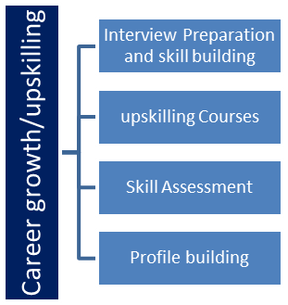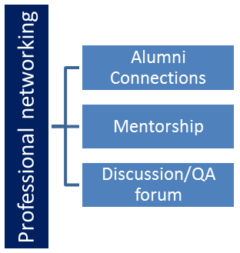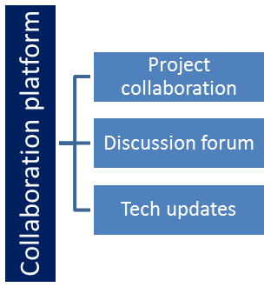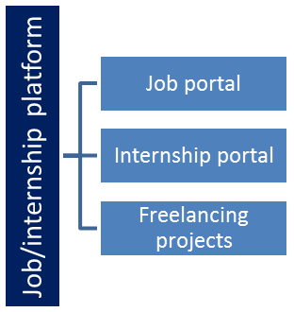

## The IoT Academy

The IoT academy is EdTech Division of UCT that is running long executive certification programs in collaboration with EICT Academy, IITK, IITR and IITG in multiple domains.

## Objectives of this Internship program

The objective for this internship program was to

 ☛ get practical experience of working in the industry.

 ☛ to solve real world problems.

 ☛ to have improved job prospects.

 ☛ to have Improved understanding of our field and its applications.

 ☛ to have Personal growth like better communication and problem solving.

## Reference

[1] udemy machine learning course

[2] coursera data science course

[3]

## Glossary

|  |  |
| --- | --- |
| Terms | Acronym |
|  |  |
|  |  |
|  |  |
|  |  |
|  |  |

# Problem Statement

In the assigned problem statement

My problem statement was to reduce the size of the image encode the images using yolo and then increase the amount of data .

Then performing det4ection machine algorithm which is based on reinforcement learning and then detection of the crop is that images is weed or crop.

# Existing and Proposed solution

Provide summary of existing solutions provided by others, what are their limitations?

Various student use normal cnn learning I used open cv.

What is your proposed solution?

My solution help to distinguish between crop and weed

What value addition are you planning?

I wanted to use similar project just changing the code littlebit.

## Code submission (Github link)

https://github.com/jagdip7/Crop-and-weed-Detecction

## Report submission (Github link) :

https://github.com/jagdip7/Crop-and-weed-Detecction

# Proposed Design/ Model

As this is the project whose data is based on reinforcement learning so I perform neural and convulational network (cnn and acc) I also used opencv to extract data in usable form I used yolo and data augmatation

## High Level Diagram (if applicable)





Figure: HIGH LEVEL DIAGRAM OF THE SYSTEM

## Low Level Diagram (if applicable)

none

## Interfaces (if applicable)

Update with Block Diagrams, Data flow, protocols, FLOW Charts, State Machines, Memory Buffer Management.

none

# Performance Test

This is very important part and defines why this work is meant of Real industries, instead of being just academic project.

Because it focuses on real life problem rather than imaginary problem provided in academic progaram

Here we need to first find the constraints.

Cleaning data

How those constraints were taken care in your design?

I used yolo app and I increase the amount of data

What were test results around those constraints?

yes

Constraints can be e.g. memory, MIPS (speed, operations per second), accuracy, durability, power consumption etc.

Constrain like high dimension and unclear data can harm the model

In case you could not test them, but still you should mention how identified constraints can impact your design, and what are recommendations to handle them.

## Test Plan/ Test Cases

My plan was to use cnn and ann using yolo and along side build a model for detection.

## Test Procedure

For test procedure I divided the data in train and test model and used cnn and open cv.

## Performance Outcome

Got the detection of image as necessary a ai model which can detect crop and weed

# My learnings

During the project I learn about various machine learning algorithm which were categories based on different type of data eg supervised,unsupervised and reinforcement learning.

as value are present we are going to perform supervised learning algorithm .as mention above I have started coding the project I tried various regression method like simple , multiple and polynomial to find out the best prediction as possible .As well as I started learning about unsupervised data and reinforcement data and came to realise that my project is well suited for regression as my data is arranged .i learned classification types like logistic and k-nearst and I learned about svm I further gain practical knowledge about the things mention above while doing so I worked on another project called salary predicitor which was based on multiple regression. I continue to learn about the reinforcement learning and I learned about open cv , neural network and cnn. I changed my project to crop and weed detection

I started working on project no 5 and as per my conclusion it was based on cnn and neural network similarly to get complete grasp of the project I worked on similar project which was to differentiate between dog and cat which was based on cnn and neural networks .

# Future work scope

As I was working on the project I got to know various library which could not only ease up the process but also will increase as we proceed as using more realistic data clean data . this project will help us to proceed high level of differentiation which cannot be done by an human eye . it can also help us to prepare various detection tool like face detection object detection.

It can help in future like emotion detection threat detection etc.